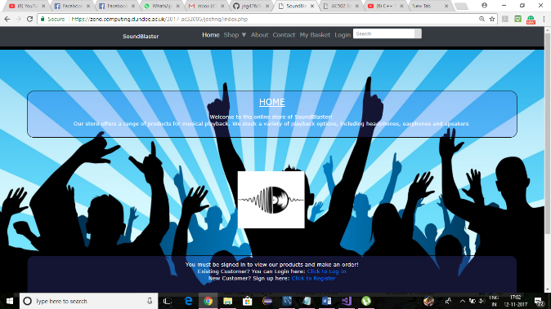User guide for Sound Blaster Application

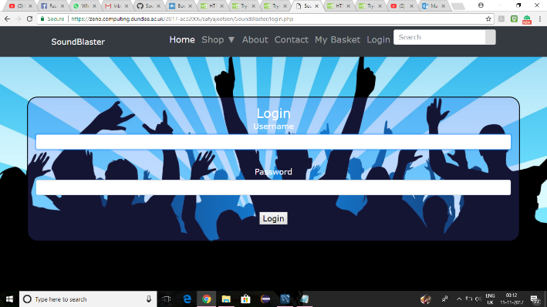

Login and Home screen page

Login credentials username:-satya password:-satya for customer

Web address:-

When customer logins,he/she can see the home page containing information about the website.The new customer can also register for the site.

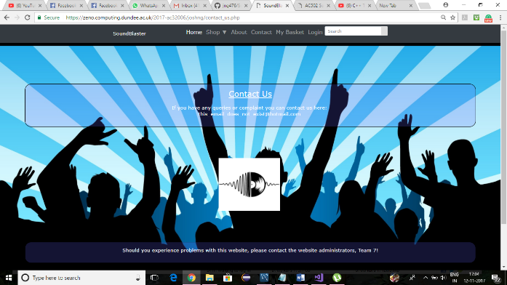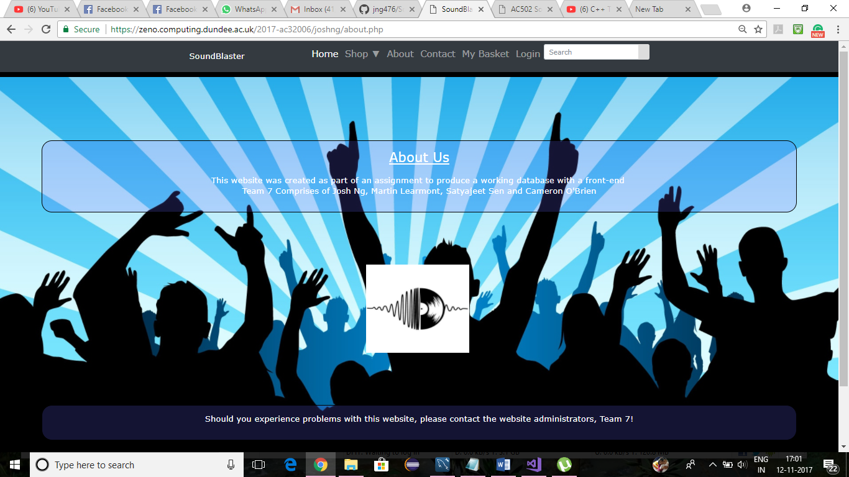

About us and Contact us page

Customer navigates by clicking the about section leads to ‘About us’ page. Also customer navigates by clicking contact section loads the ‘Contact us’ page.

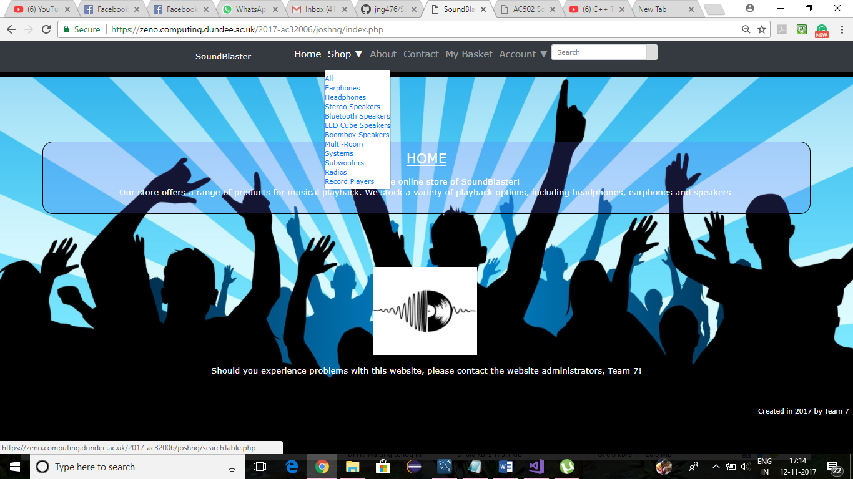

Shop dropdown

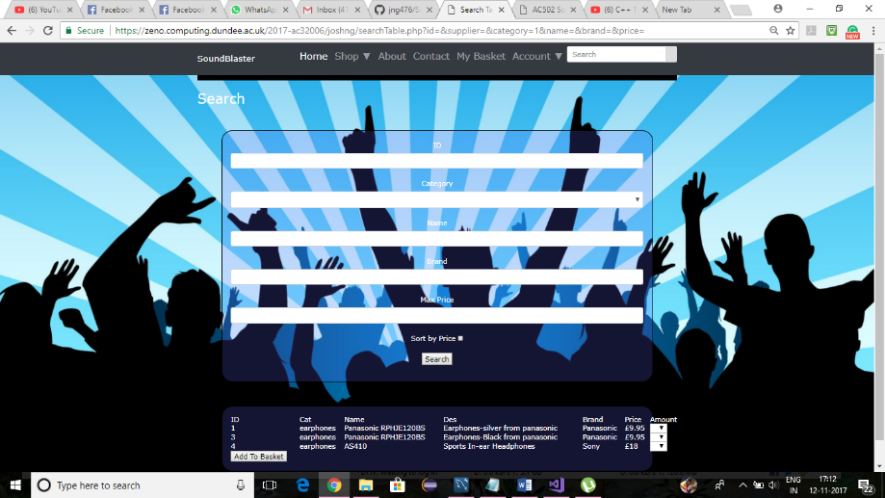

Shop/Earphones page

When customer clicks on shop dropdown at menu bar, he/she can see range of items list for sale(for example earphones, headphones, stereo speakers, bluetooth speakers etc.).On clicking the earphones link a new search page appears giving description about all the earphones available for sale. On clicking all link from shop dropdown gives all the list of products available for sale. The user(customer) can also search for list of products by typing in ID, Category, Name, brand and maximum price.

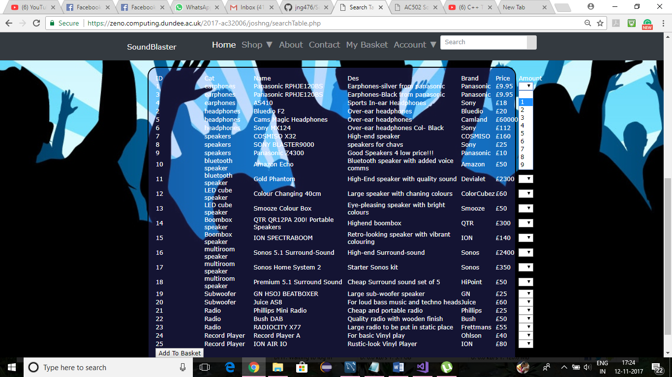

Shop/All page

In the list of products available, a customer can choose the amount or quantity of products he/she needs and then add to basket.

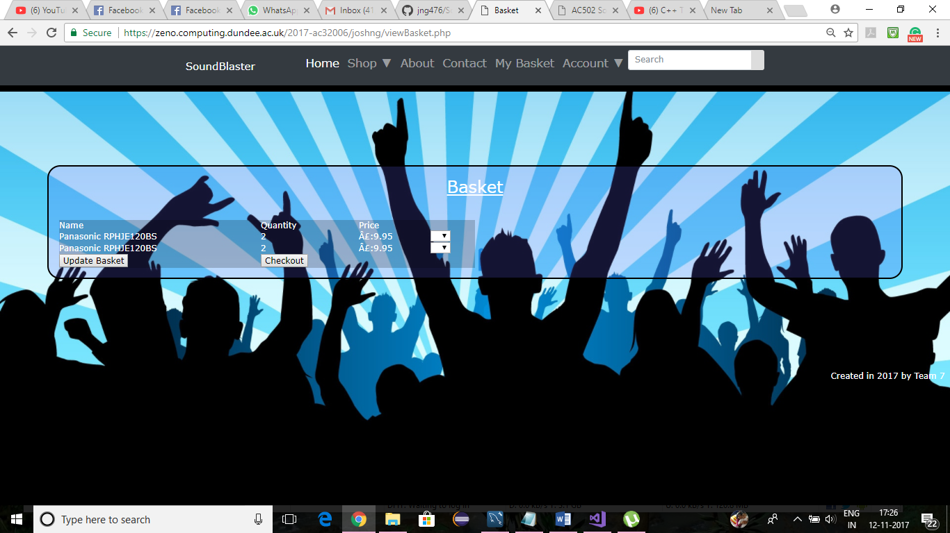

Add to Basket Page

Adds the list of products and quantity to the basket. The customer can checkout the list of products he/she wants or can update the basket as well.

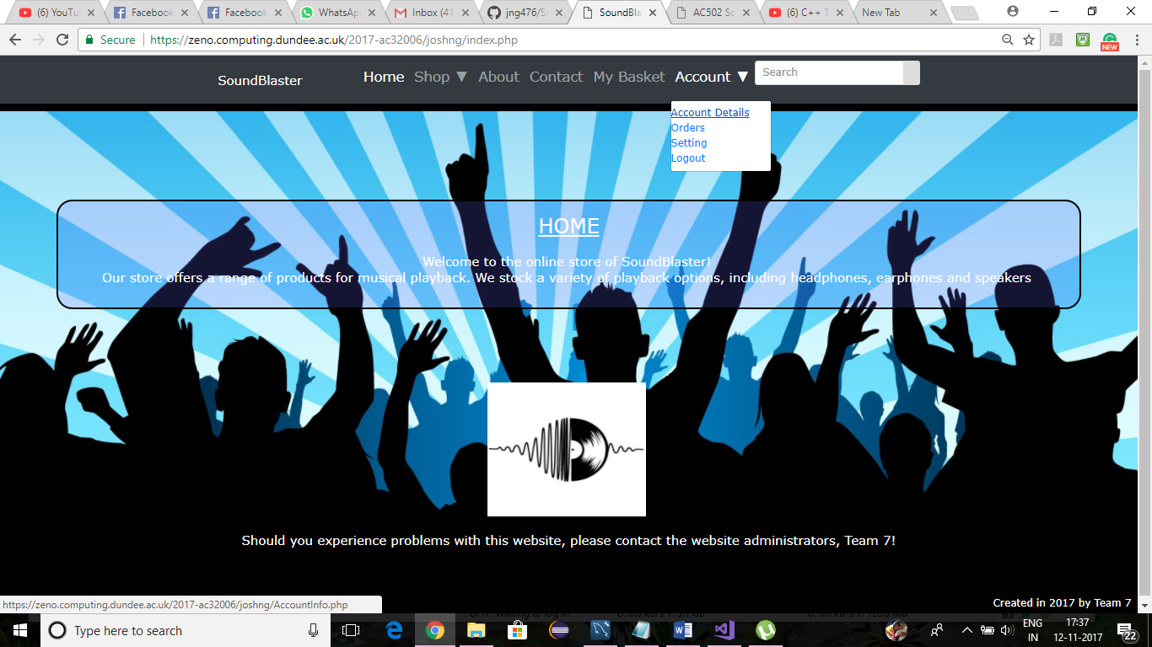

Account dropdown

On clicking the account dropdown in menu bar the customer can see account details, orders he created in the past, settings and logout of the website.

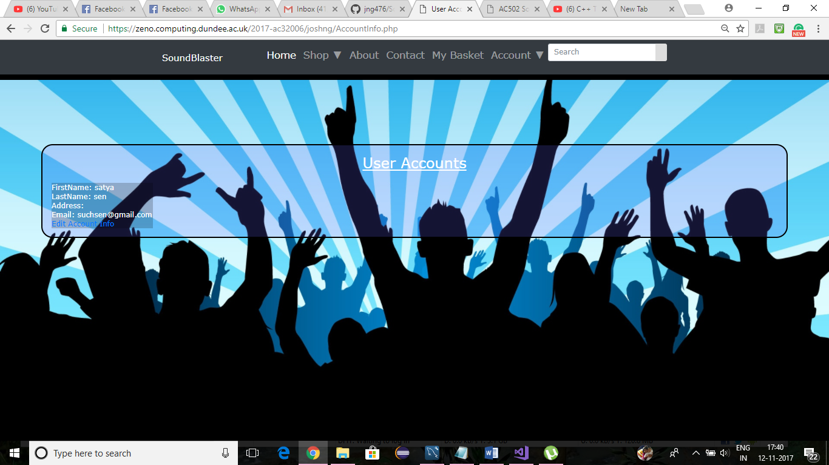

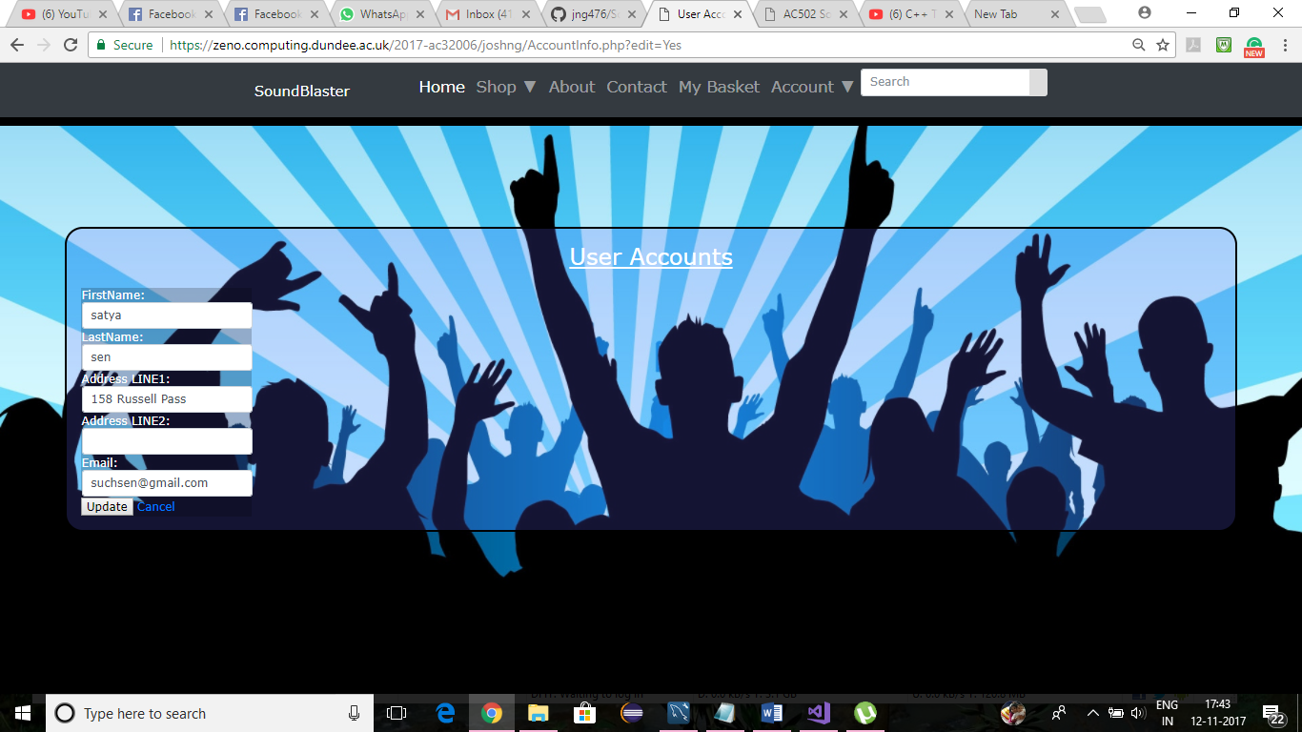

Account/Account Details

The user can see account details consisting of first name, last name, address and email and can update the information by clicking edit account info.

‘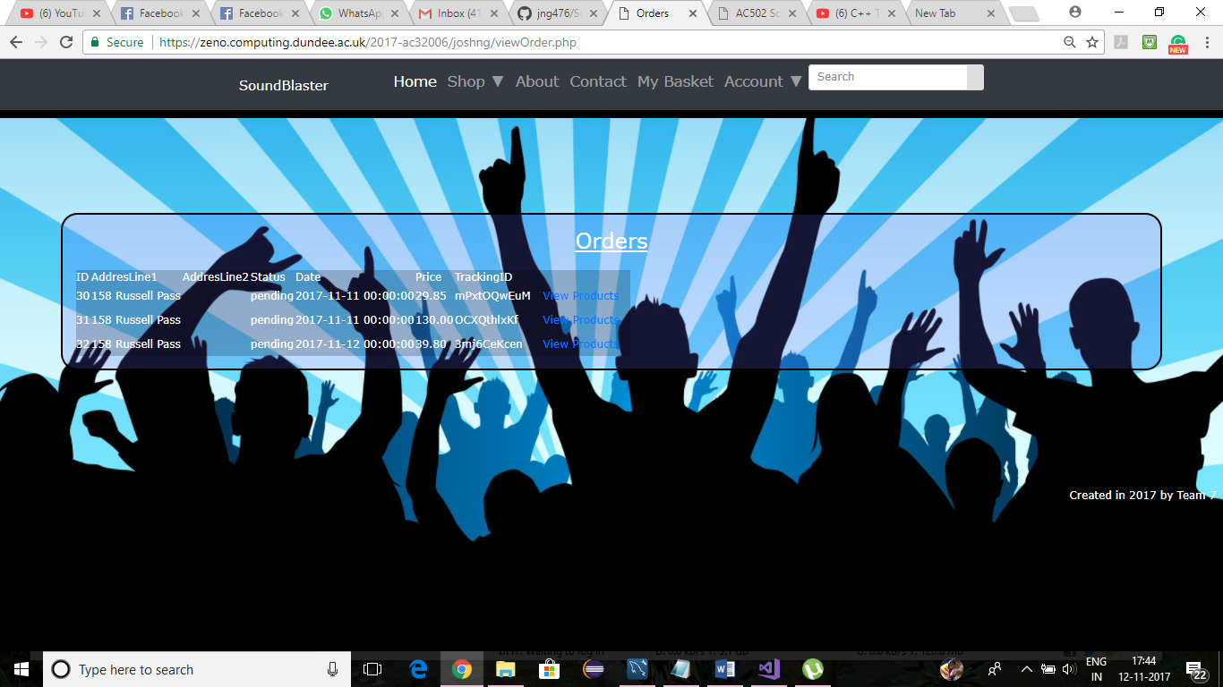

Account/Orders

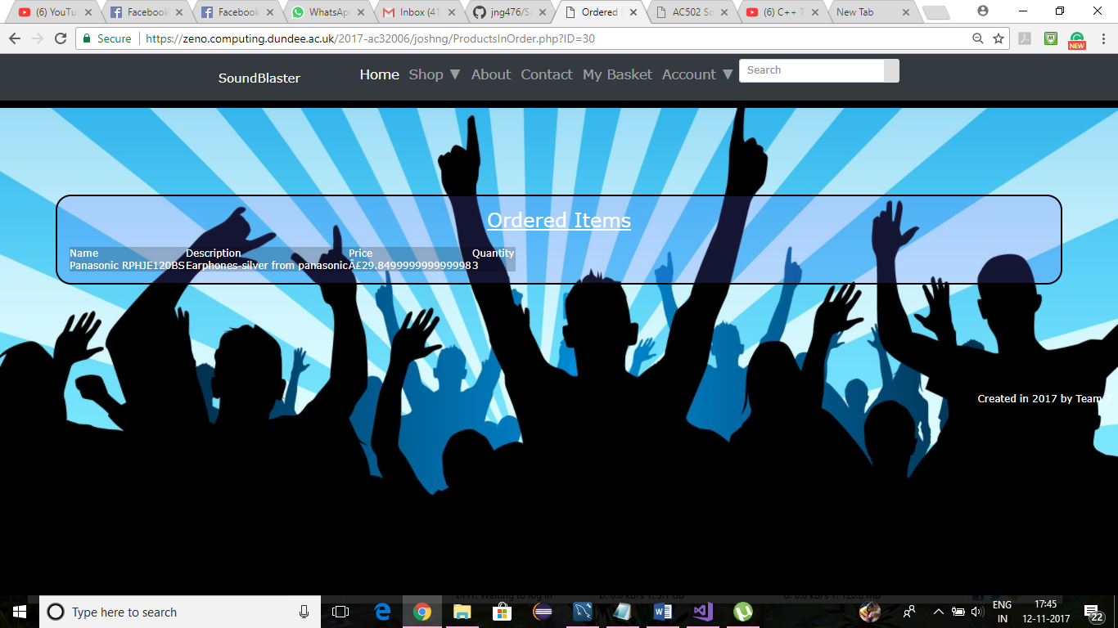

Account/Orders/view products

The customer can view any past orders against his/her name. It shows id, address, tracking order number, status of order, date of order and price of order. On clicking view products link, it shows the list of ordered items which includes Name, description, price and Quantity.

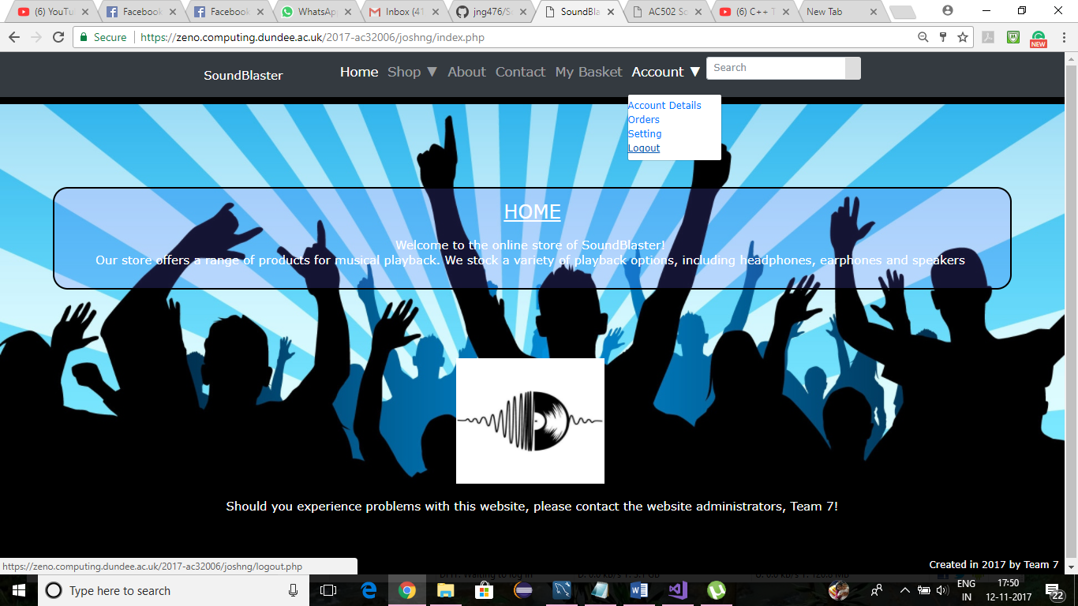

Account/logout

A customer can logout from the website by clicking on accounts on menubar and logout link.